PROJECT DESIGN

|  |  |
| --- | --- |
| **TEAM ID** | NM2025TMID02997 |
| **PROJECT NAME** | Educational Organisation Using ServiceNow |

## Proposed solution template:

Project team shall fill the following information in the proposed solution template

|  |  |  |  |  |
| --- | --- | --- | --- | --- |
|  | | | |  |
|  | **S.No** | **Parameter** | **Description** |  |
|  | 1. | Problem Statement (Problem to be sloved) | ServiceNow helps educational institutions replace manual, disconnected processes with a unified platform⁸ to improve efficiency, service delivery, and  user experience. |  |
|  | 2. | Idea/solution Description | Implement ServiceNow to centralize services, automate workflows, and integrate departments— enabling faster support, better communication, and improved experiences for students, faculty, an  staff. | d |
|  | 3. | Novelty/uniqueness | ServiceNow uniquely offers a unified, low- |  |

|  |  |  |  |  |
| --- | --- | --- | --- | --- |
|  |  |  | code platform tailored for education, enabling cross-department automation, real-time visibility, and seamless self- service—all in one  scalable solution. |  |
|  | 4. | Social impact / customer satisfaction | ServiceNow improves satisfaction by providing faster, transparent support, empowering student and staff with self- service tools, and enhancing overall campus service  experiences. | s |
|  | 5. | Business model(revenue model | Educational institutions invest in ServiceNow to reduce operational costs, improve service efficiency, and enhance student satisfaction—leading to better retention, optimized resources, and long-term  institutional growth. |  |
|  | 6. | Scalability of the solution | ServiceNow easily scales with institutional growth, allowing seamless addition of users, departments, and  services without compromising |  |

|  |  |  |  |  |
| --- | --- | --- | --- | --- |
|  |  |  | performance or user experience. |  |

## Educational organization using

**Services now**

**Milestone 1:** Setting up ServiceNow instance

**Activity 1:**

# Setting Up ServiceNow Instance

1. Sign up for a developer account on the ServiceNow Developer site

“https://developer.servicenow.com”.

1. Once logged in, navigate to the "Personal Developer Instance" section.
2. Click on "Request Instance" to create a new ServiceNow instance.
3. Fill out the required information and submit the request.
4. You'll receive an email with the instance details once it's ready.
5. Log in to your ServiceNow instance using the provided credentials.
6. Now you will navigate to the ServiceNow.

Milestone 2:Creating a update set

Activity 1 :1Click on All >> Local update sets

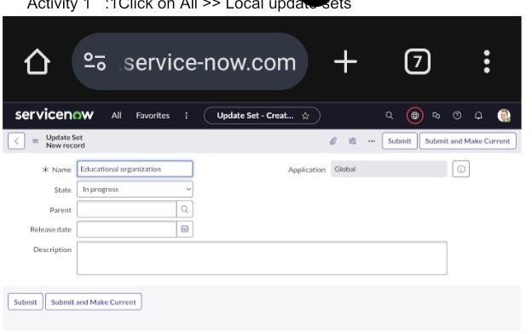

Click on and make Current.

3. .Enter the Details Name: Educational Organisation >> Click on Submit and make Current.

Milestone 3:Creating a table

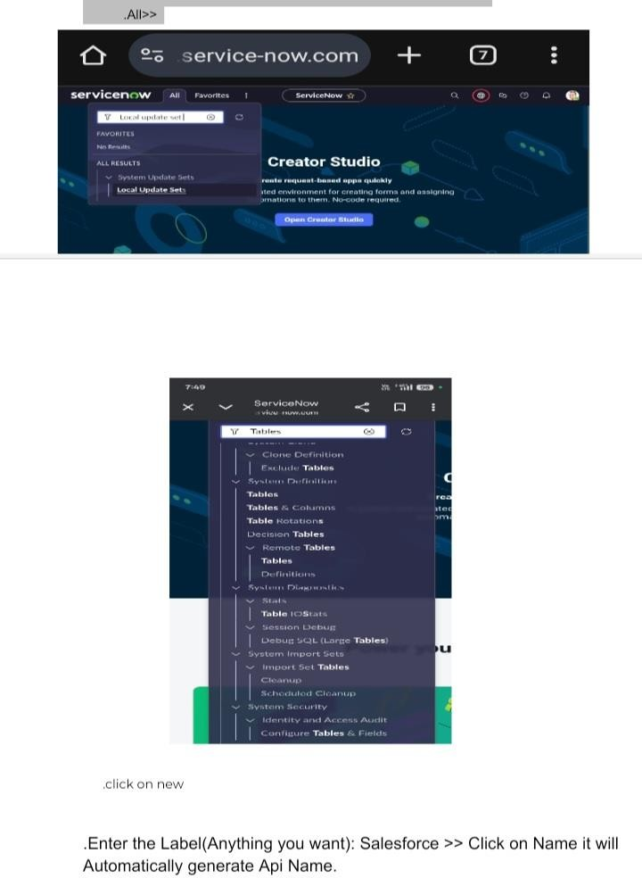

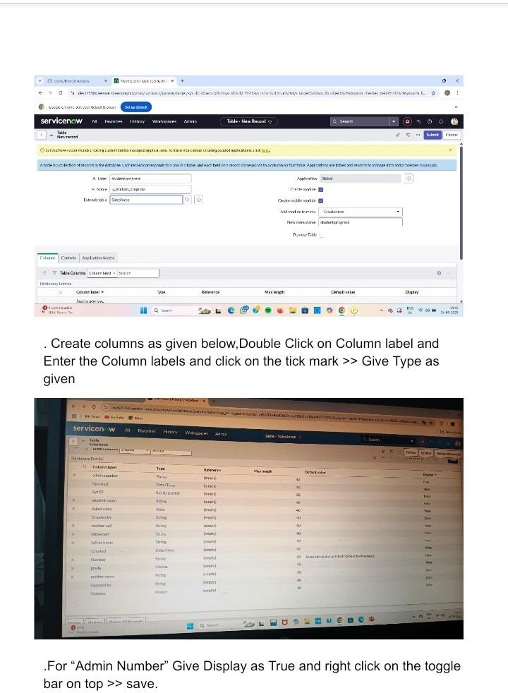

Click on controls >> Enable Extensible.

**.**Click on “Admin Number” column, In Related Links Click on Advanced View >> Default View (Enable Use dynamic default) >> select Get Next Padded Number in Dynamic default value >> Update .

.Click on “Grade” Column >> Click on Choices and give Label,Value and

Sequence as given below.Tableac Activity 2:

## .Creating Admission Table

.Create an Admission Table with Columns given.

.Select Extends Table >> Salesforce and also Select Add module to menu

>> Salesforce.

* .create Fields as Shown

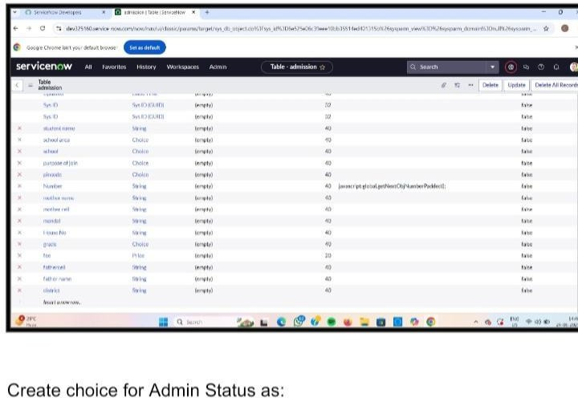

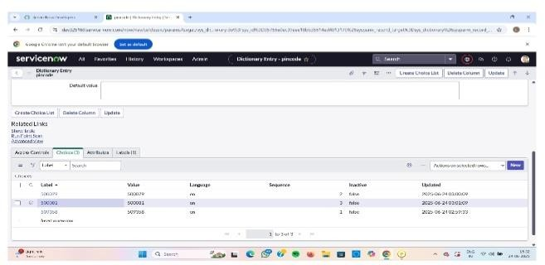

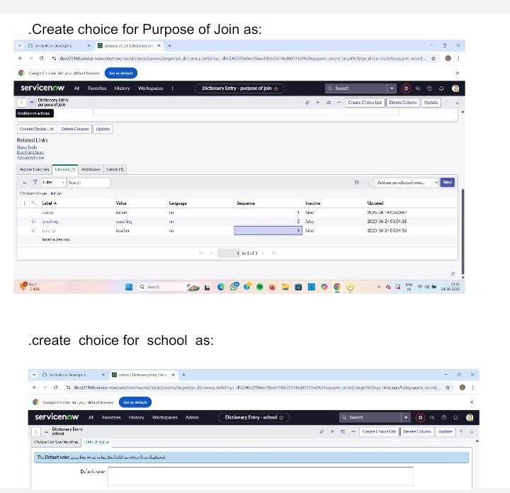

.create choice for School Area as:

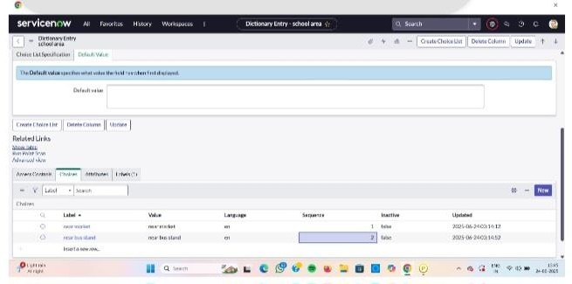

Activity 3:

Creating Student Progress Table

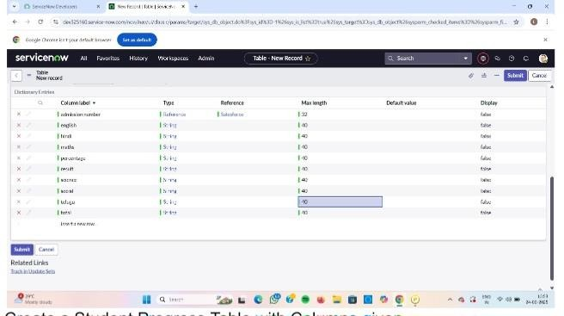

Create a Student Progress Table with Columns given.

.Select Add module to menu >> Salesforce.

.Create Fields as shown:

Milestone 4:Form layout

Activity 1:Configuring Table Form For Student Progress Table In the Student Progress Table Page , Click on Layout form .

Click on Admission Number [+] .

. Select below Admission Number fields in Available side and send it to selected side as below

Milestone 5: Form design

Activity: Creating Form Design For Salesforce Table

.All >> System Definition >> Tables .

.In Label Search for Salesforce and open .

Right Click on top Toggle >> Configure >> Form

.Drop down select Salesforce(u_salesforce).

. Drag and drop the fields to the left side as below.

**Activity 2:**

# Creating Form Design For Admission Table

Follow the same steps as Activity1,Configure the fields as below and Save

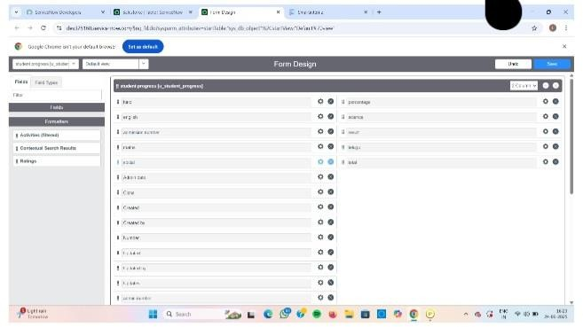

**Activity 3:**

Creating Form Design For Student Progress Table

Follow the same steps as Activity1,Configure the fields as below and Save

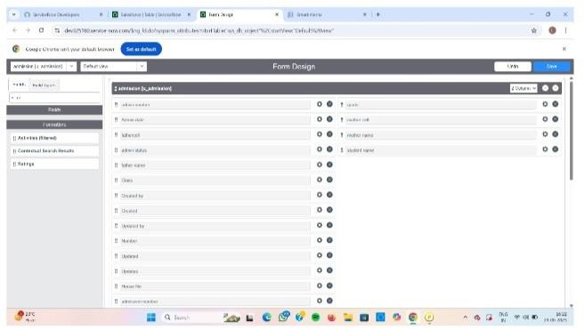

**Milestone 6: Number maintenance**

Activity 1:

Creating Number Maintenance For Admin Number

.All >> Number Maintenance >> New

.Fill the details >> Submit

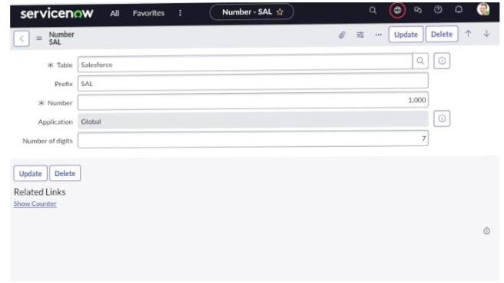

Activity1 :Creating Process Flow For Admission Table All >> Process Flow>> New.

Fill the Details as given Below

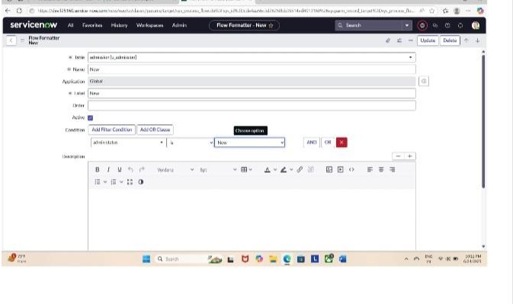

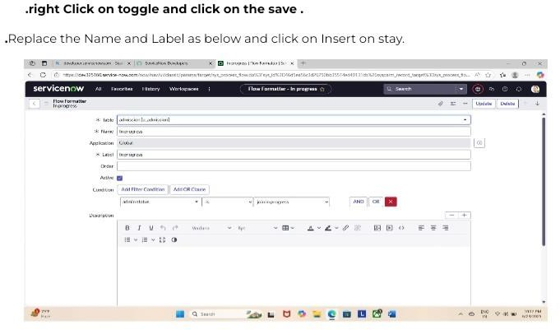

Replace the Name and Label in order and click on Insert on stay.

.Joined >> Rejected >> Rejoined >> Closed >> Cancelled.

.Order should be New >> IN Progress >> Joined >> Rejected >> Rejoined >> Closed >> Cancelled.

MILESTON 8: client scripts

Activity 1:

Creating “Auto Populate” Client Scripts For Admission Table All >> Client Scripts >> New.

Fill the Details as given

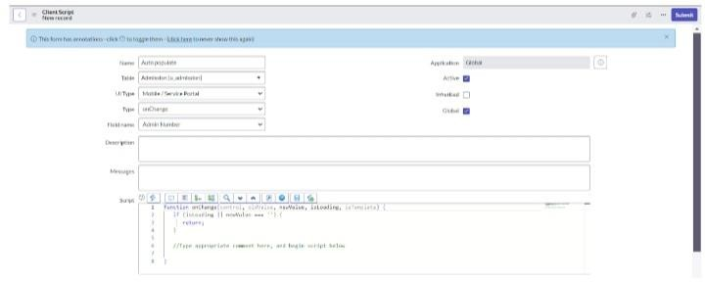

G_form.setValue(‘u_student_name’,a.u_student_name); G_form.setValue(‘u_father_name’,a.u_father_name); G_form.setValue(‘u_mother_name’,a.u_mother_name); G_form.setValue(‘u_father_cell’,a.u_father_cell);

G_form.setValue(‘u_mother_cell’,a.u_mother_cell);Creating “Auto Populate”

Client Scripts For Admission Table All >> Client Scripts >> New.

Fill the Details as given.

Write the Code as below, Enable Isolate script and Save.

Function onChange(control, oldValue, newValue, isLoading, isTemplate) {

If (isLoading || newValue === ‘’) {

Return;

}

//Type appropriate comment here, and begin script below Var a = g_form.getReference(‘u_admission_number’); G_form.setValue(‘u_admin_date’,a.u_admin_date); G_form.setValue(‘u_grade’,a.u_grade);

G_form.setDisabled(‘u_admin_date’,a.u_admin_date); G_form.setDisabled(‘u_grade’,a.u_grade); G_form.setDisabled(‘u_student_name’,a.u_student_name); G_form.setDisabled(‘u_father_name’,au father name); G_form.setDisabled(‘u_mother_name’,a.u_mother_name); G_form.setDisabled(‘u_father_cell’,a.u_father_cell); G_form.setDisabled(‘u mother_cell);

}

Note: Make sure the Field names should be the same as you created

G_form.setValue(‘u_city’, ‘AsifNagar’); G_form.setValue(‘u_district’, ‘Hyderabad’);

}

//Type appropriate comment here, and begin script below

**}**

**Activity 3:**

**Creating “Disable Fields” Client Scripts For Student Progress Table**

**.**Fill the Details as given.

Write the Code as below, Enable Isolate script and Save. Function on Load() {

//Type appropriate comment here, and begin script below G_form.setDisabled(‘u_total’,true); G_form.setDisabled(‘u_percentage’,true); G_form.setDisabled(‘u result’, true);

}

**Activity 4:**

# Creating “Total Update” Client Scripts For

Student Progress Table

* Fill the Details as given.

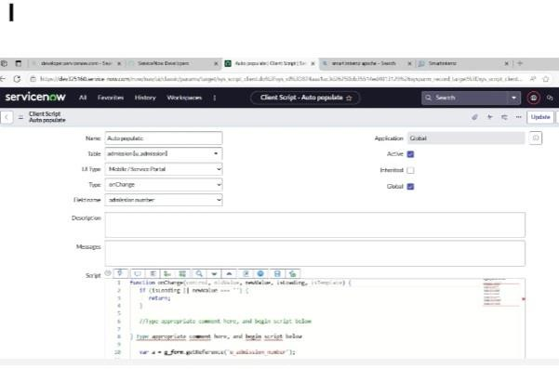

Write the Code as below, Enable Isolate script and Save.

Function on Change(control, oldValue, newValue, isLoading, isTemplate) {

If (isLoading || newValue === ‘’) {

Return;

**}**

//Type appropriate comment here, and begin script below

If (newValue){

Var a = parseInt(g_form.getValue(‘u_telugu’));

Var b = parseInt(g_form.getValue(‘u_hindi’));

Var c = parseInt(g_form.getValue(‘u_english’));

Var d = parseInt(g_form.getValue(‘u_maths’));

Var e = parseInt(g_form.getValue(‘u_science’));

Var f = parseInt(g_form.getValue(‘u_social’));

Var Total = parseInt(a+b+c+d+e+f);

G_form.setValue(‘u_total’, Total);

**}**

**}**

Activity 5:

Creating “Result” Client Scripts For Student Progress Table

.fill the Details as

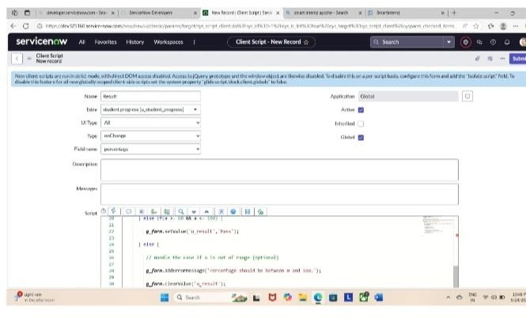

Write the Code as below, Enable Isolate script and Save.

Function on Change(control, oldValue, newValue, isLoading, isTemplate) {

If (isLoading || newValue === ‘’) {

Return;

**}**

//Type appropriate comment here, and begin script below

If(newValue) {

Var a = parseInt(g_form.getValue(‘u_percentage’)); // Convert the value to an integer for comparison

If (A >= 0 ss a <= 5G){

G_form.setValue(‘u_result’,’Fail’);

} else if(a >= 60 ss a <= 100) {

G_form.setValue(‘u_result’,’Pass’);

} else {

// Handle the case if a is out of range (optional)

G_form.addErrorMessage(‘Percentage should be between 0 and 100.’);

G_form.clearValue(‘u_result’);

**}**

**}**

**}**

Activity 6:

Creating “Percentage” Client Scripts For Student Progress table

.fill The Details as given

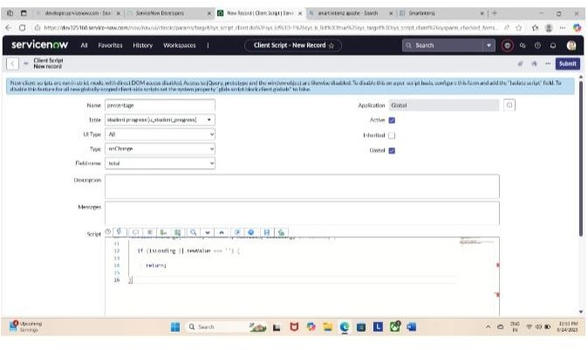

Creating “Percentage” Client Scripts For Student Progress Table Fill the Details as given.

Write the Code as below, Enable Isolate script and Save.

Function on Change(control, oldValue, newValue, isLoading, isTemplate) {

If (is Loading || newValue === ‘’) {

Return;

**}**